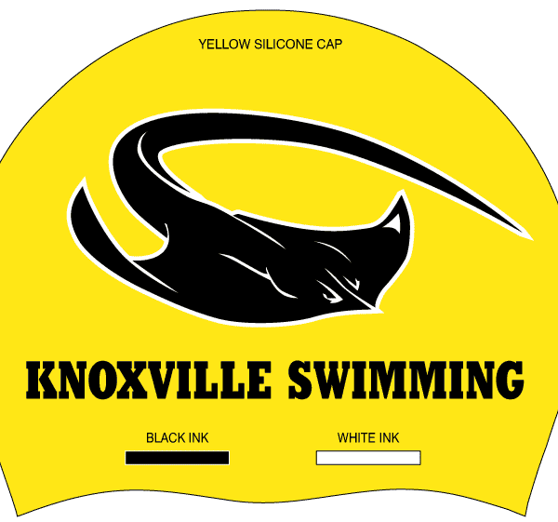

Knoxville Swim Team Caps FOR SALE:

$11.00 per cap
Make checks payable to KNOXVILLE SWIM TEAM
Returns not accepted!
One size fits all!

